**OS ASSIGNMENT 1**

1. Write a C/C++ code to demonstrate round-robin algorithm.

***#Program***

#include<iostream>

#include<iomanip>

#include<cstring>

using namespace std;

int main()

{

int n,q;

cout<<"C++ Program to implement ROUND ROBIN Algorithm."<<endl;

cout<<"Enter number of processes : ";

cin>>n;

int arr[n],bur[n],ord[n];

for(int i=0;i<n;i++)

{

cout<<endl<<"Enter following details for process "<<(i+1)<<endl;

cout<<"Arrival time : ";

cin>>arr[i];

cout<<"Burst time : ";

cin>>bur[i];

ord[i]=(i+1);

}

cout<<endl<<"Enter quantum time : ";

cin>>q;

cout<<endl<<"______________________________________"<<endl;

cout<<"| Process | Arrival Time | Burst Time |"<<endl;

cout<<"|_________|______________|____________|"<<endl;

for(int i=0;i<n;i++)

cout<<"|P"<<left<<setw(8)<<ord[i]<<"|"<<left<<setw(14)<<arr[i]<<"|"<<left<<setw(12)<<bur[i]<<"|"<<endl;

cout<<"|_________|______________|____________|"<<endl;

for(int i=0;i<n-1;i++)

{

for(int j=0;j<n-1-i;j++)

{

if(arr[j]>arr[j+1])

{

swap(ord[j],ord[j+1]);

swap(arr[j],arr[j+1]);

swap(bur[j],bur[j+1]);

}

}

}

int wt[n],te[n],rt[n];

cout<<endl<<"The order in which the processes are executes is : "<<endl;

int j=0;

int ts=0;

for(int i=0;i<n;i++)

{

rt[i]=bur[i];

wt[i]=0;

te[i]=0;

}

while(j<=n)

{

j++;

for(int i=0;i<n;i++)

{

if(rt[i]==0)

continue;

if(rt[i]>q)

{

cout<<"P"<<i+1<<" ";

ts=ts+q;

rt[i]=rt[i]-q;

te[i]=te[i]+1;

}

else

{

cout<<"P"<<i+1<<" ";

wt[i]=ts-te[i]*q;

ts=ts+rt[i];

rt[i]=rt[i]-rt[i];

}

}

}

cout<<endl;

int total_wt=0,total_tat=0;

for(int i=0;i<n;i++)

{

wt[i]=wt[i]-arr[i];

total_wt=total_wt+wt[i];

}

int tat[n];

for (int i=0;i<n;i++)

{

tat[i]=bur[i]+wt[i];

total_tat = total_tat + tat[i];

}

cout<<endl<<"Average waiting time = "<< (float)total_wt / (float)n<<endl;

cout<<"Average turn around time = "<< (float)total_tat / (float)n<<endl;

cout<<endl<<endl;

return 0;

}

***Output***

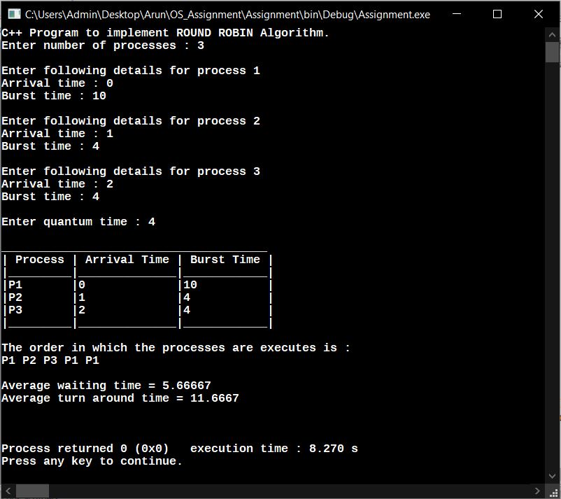

1. Write a C/C++ code to demonstrate FCFS algorithm.

***#Program***

#include<iostream>

#include<iomanip>

#include<cstring>

using namespace std;

int main()

{

cout<<"C++ Program to implement FIRST COME FIRST SERVE Algorithm."<<endl;

int n;

cout<<"Enter number of processes : ";

cin>>n;

int arr[n],bur[n],ord[n];

for(int i=0;i<n;i++)

{

cout<<endl<<"Enter following details for process "<<(i+1)<<endl;

cout<<"Arrival time : ";

cin>>arr[i];

cout<<"Burst time : ";

cin>>bur[i];

ord[i]=(i+1);

}

cout<<endl<<"______________________________________"<<endl;

cout<<"| Process | Arrival Time | Burst Time |"<<endl;

cout<<"|_________|______________|____________|"<<endl;

for(int i=0;i<n;i++)

cout<<"|P"<<left<<setw(8)<<ord[i]<<"|"<<left<<setw(14)<<arr[i]<<"|"<<left<<setw(12)<<bur[i]<<"|"<<endl;

cout<<"|_________|______________|____________|"<<endl;

cout<<endl<<"The order in which the processes are executes is : "<<endl;

for(int i=0;i<n;i++)

cout<<"P"<<ord[i]<<" ";

cout<<endl;

int wt[n], tat[n], total_wt = 0, total_tat = 0;

wt[0]=0;

for(int i=1;i<n;i++ )

wt[i]=bur[i-1]+wt[i-1] ;

for (int i=0; i<n; i++)

{

tat[i]=bur[i]+wt[i];

total_wt = total_wt + wt[i];

total_tat = total_tat + tat[i];

}

cout<<endl<<"Average waiting time = "<< (float)total_wt / (float)n<<endl;

cout<< "Average turn around time = "<< (float)total_tat / (float)n<<endl;

cout<<endl<<endl;

return 0;

}

***Output***

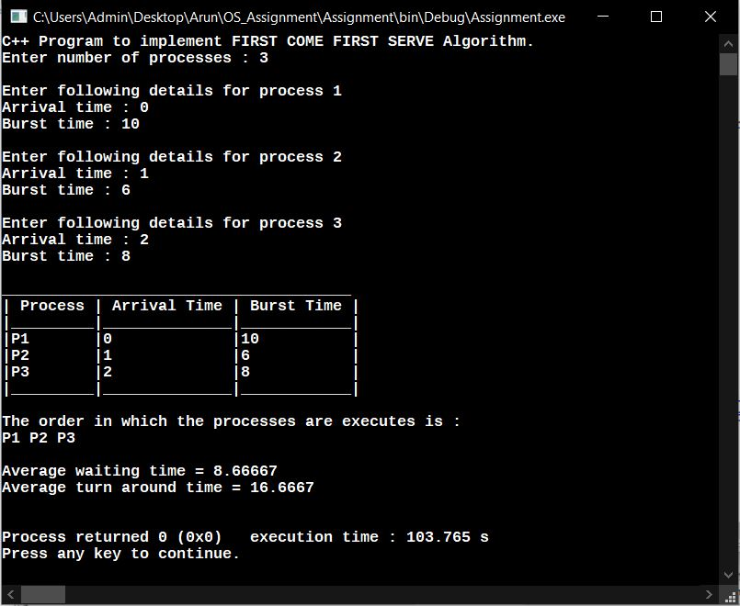

**BY:**

ARUN P N

1SI17IS007

**Date of Submission:**

10-Oct.-2019